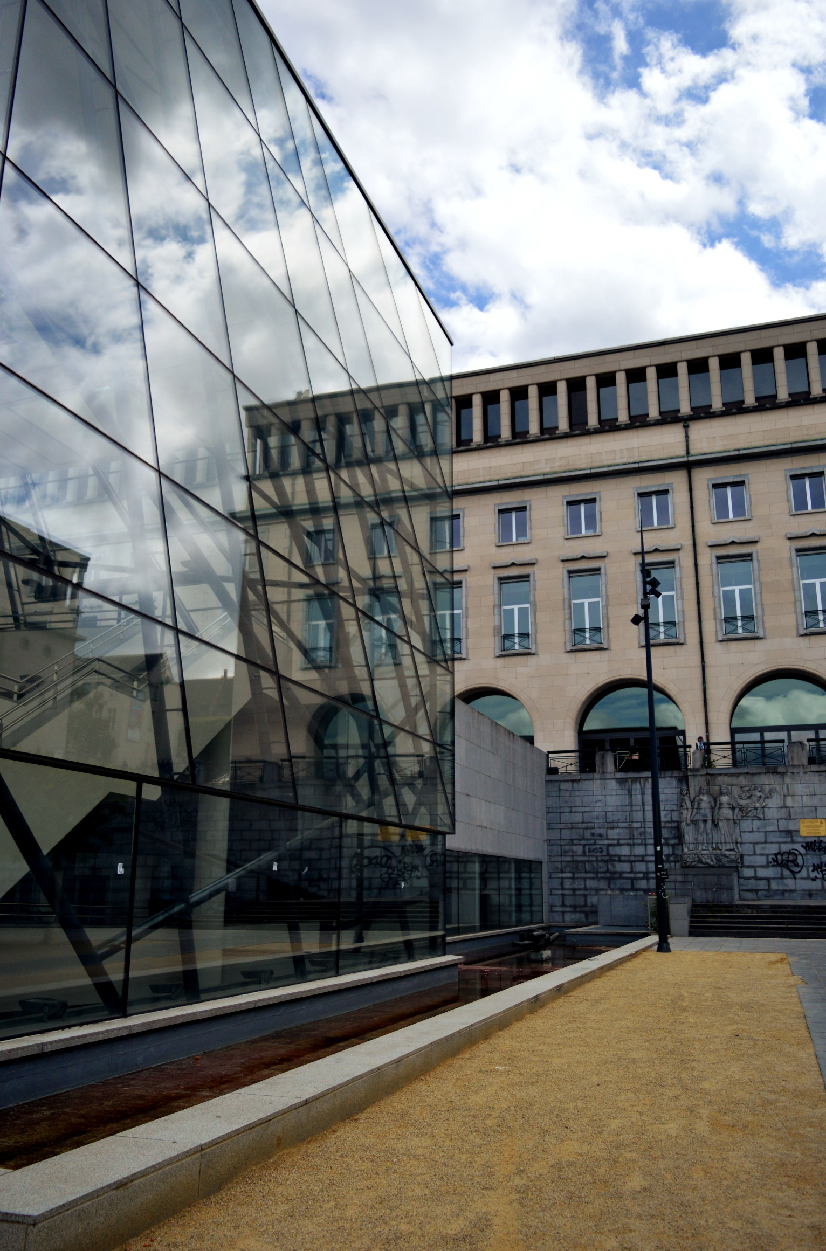

VSZ – ASTER applying for the organization.

WFHSS Congress 2023

BRUSSELS

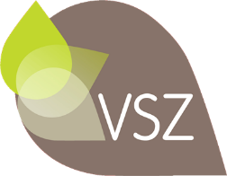
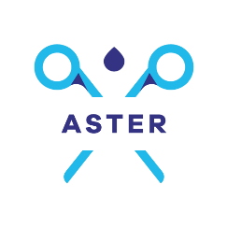

Belgium's application to host the 23rd WFHSS Congress.
The organisations:
ASTER an organization based in Wallonia (southern part of the country)with 150 individual members and about 20 industrial members who support the joint application. This represents more or less 300 people actively present at each of the 21 congresses and 7 members' days that the association has organized since its foundation in 1988. ASTER, a founding member with SSSH, SF2S and SMS also organized the 3rd JIFS “Journées Internationales Francophones de Stérilisation” in 2014.
Aster is a member of WFHSS and of the General Union of Belgian Nurses (UGIB) and currently holds a UGIB mandate as vice president within Mdeon (common ethical platform) and has filed a candidacy within the UGIB to represent it on the Federal Council of Nursing.

VSZ an organization based in Flanders (northern part of the country) with 200 individual members founded in 1985 has organized 35 congresses and as many practical training days since its foundation. As co-founder of the WFHSS and EFHSS the VSZ organized the European Days in 2002 in Bruges.

ASTER and the VSZ have been working together for many years to improve the quality regarding sterilization in Belgium:
- 2015-2017 within the Higher Health Council, the drafting of good sterilization practices (ISBN 9789490542528).
- 2017 within the FAMHP (Agency for Medicines and Health Products) for the drafting of the conditions for reprocessing single-use medical devices- 2020 - 2021 advice was given in the context of the COVID19 pandemic crisis (reprocessing of single-use masks, shortage of polypropylene packaging, manufacture/reprocessing of PPE, etc.)
- 2021 revisions of training programs for sterilization co-workers and nurses specialized in sterilization.
Request for revision of recommendations for prevention of prion disease.
We have 2 bilingual board members in common to both associations.

The organizing committee for the 23rd edition of the WFHSS Congress

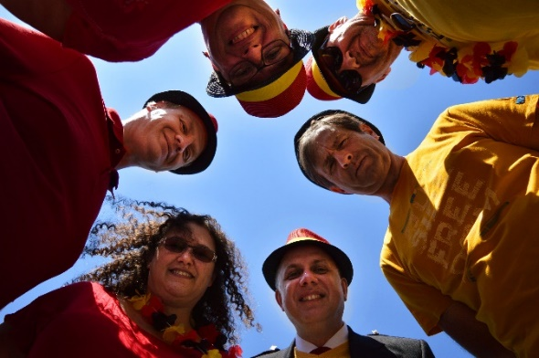
Isabelle de la Charlerie ; President of ASTER
Krist Henrotin; President of the VSZ
Sandrine Frédéric; Vice president of ASTER
Michel Renson; secretary ASTER
Sigurd Vandendriessche; administrator ASTER-VSZ
Bart Gabriels; VSZ administrator
Thomas Onsea; Vice president of VSZ

The organizing committee, mandated by both associations, is committed
- to work actively with the WFHSS core PCO for the organization of the congress,
- to sign a contract with it and to pay it
- to collaborate with the WFHSS committee in the scientific framework of the organization and agree to the guidelines for WFHSS Annual Congress Organization.

Belgium is a small country with an international appearance.
Belgium is a reference in diplomacy, business, research and development and ... sterilization.
In the last 10 years, the countries of Central Europe have been organizing the World Congress, a Belgian organization in 2023 would be the concretization of a strength, a European cohesion in terms of good sterilization practices, scientific and technological exchanges.
Belgium innovates in sterilization:
- Research in detergents is active through the production of ecological detergents or means of detecting proteins and their destruction.
- High-performance traceability software adapted to Belgian specificities and good sterilization practices, while meeting customer demands (operating theatres, endoscopy, etc.) and legal and normative requirements.
- Innovative models of outsourcing of sterilization activity, private sterilization, distribution, and management of ancillary equipment on loan adapted to the needs of implant suppliers and the demands of hospitals.
- - Belgian hospitals are investing heavily in the renovation or construction of state of the art CSSD’s. The models adopted are multiple; pooling of resources, centralization, outsourcing,…

Brussels, capital of Belgium and the European Union, will host the 2023 edition of the WFHSS congress between 17 and 20 October 2023.

In addition to our industrial partners who have been loyal supporters for over 30 years, our bid is supported by the City of Brussels, the Brussels-Capital Region, the Flemish Region and the Wallonia-Brussels Federation.
The tourist office of the city of Brussels (Visit Brussels, https://visit.brussels/en), experienced in welcoming international delegations, is our privileged partner for the organization and support necessary for the choice of the congress center but also of the exceptional places in Brussels for the organization of the opening -and gala ceremonies. Visit Brussels is at the disposal of congress participants for advice and organization of cultural, festive and above specialized in everything related to all gourmet visits in the Belgian spirit.
Brussels is accessible by plane from more than 30 countries with direct flights. The national airline company, Brussels Airlines, offers a discounted rates to the participants of the WFHSS congress. The Congress Center “The Square” [https://www.square-brussels.com/en/], reachable within 5 minutes by train from Brussels airport, is located in the heart of the capital, 200 meters from the Grand Place and the cultural and cherry sites of the Belgian capital. The Conference Center offers all facilities for simultaneous translation. The committee wishes to allow as many people as possible to participate to the conferences. In addition to English and Spanish, we offer a translation into the three Belgian national languages: German, Dutch and French.
The choice of hotel is diverse with different categories of hotels around the congress centre to meet the needs and budgets of participants. Visit Brussels has already negotiated discouted rates for all participants.
The industrialists, partners of the WFHSS, have an offer of exceptional places, either breath-taking or cosy, to receive their clients and guests. Visit Brussels is at their disposal to support them in the choice of a venue adapted to the organization, philosophy and objectives of a convivial evening.
Our Belgian partners, industrialists or hospitals, are full of ideas to show our participants that sterilization is at the centre of their concerns by visiting CSSD’s, production workshops or material production Centers.
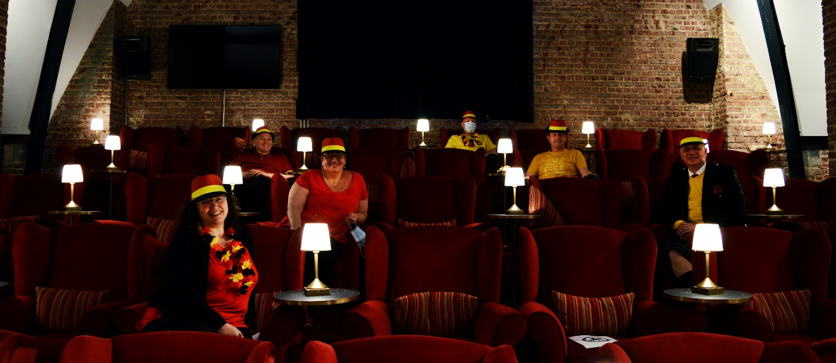
Belgium is a small country, so we have the possibility to organise various site visits from Brussels.

We look forward to seeing you in Brussels in 2023!

